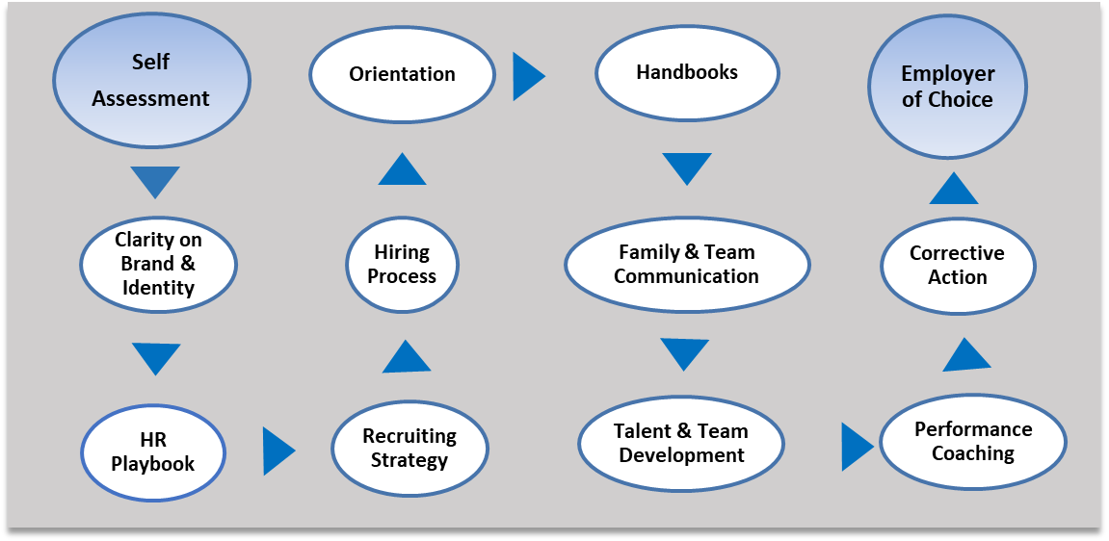
Employee Relations
Benefits &
Compensation
Increasing Skill Levels
Health, Safety & Security
Recordkeeping &
Legal Compliance
Compliance
Feedback Loop for Continuous Improvement
Attracting the Best Talent
Copyright, 2020. The Learning Connection.
Key Points of the HR Management System:
- The effect of implementing a complete HR system is achieving the status of Employer of Choice in your community
- Leadership is responsible for improving the system. Everyone is responsible for identifying better practices.
- The aim of the system is to identify, groom and retain potential successors; apply that principle across the system.
- Conflict can be a barrier within the system or it can be a tool to increase productivity from the system.
- HR must be somebody’s job!

Onboarding

